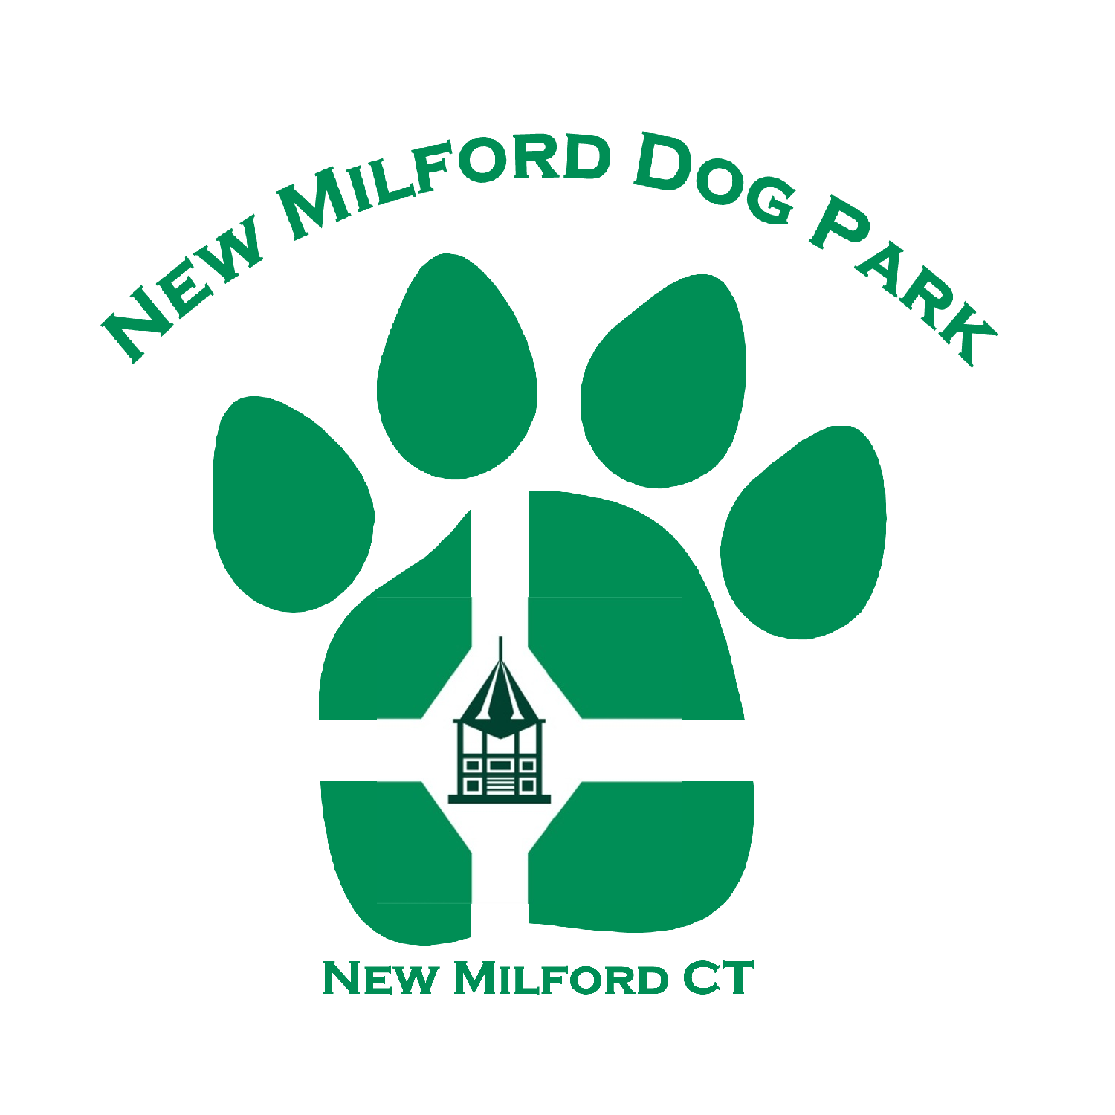
New Milford Dog Park a non- profit, volunteer run dog park. Funded only by donations. We are not in any way funded by the town of New Milford.

Name:____________________________________ | Email: _________________________________________
Address:________________________________  Address:  Town, St Zip:____________________________ | Phone: (_______)________________________  Mobile: (_______)________________________

I have ______ dog(s). Their name(s) is/are: ____________________________________________
____________________________________________
____________________________________________

I would be interested in (please check all that apply):

- General Support (meetings)
- Fundraising Committee
- Park/Grounds Maintenance
- Community Affairs
- Leadership (Board Position)
- Volunteering at Events
- Website
- PR / Media Support

I have the following skills/qualities that I would be willing to donate to NMDP:

___________________________________________________________________________________

I hereby certify that I agree to abide by the Rules of New Milford Dog Park and adhere to all terms in, the New Milford Dog Park Bylaws to uphold my membership status.

Signature
Authorized Signature: |  | Date:

Please check off the amount you wish to donate:

$20.00_________________________________(General Supporter)

$50.00_________________________________ (Acknowledgement on website and kiosk)

$100.00_________________________________(Green Paw Supporter) 6 inch Plaque w/ name on the fence

$250.00_________________________________(Silver Paw Supporter) 8 inch Plaque w/name on fence

$500.00_________________________________(Golden Bone Award) 16 inch golden bone w/name on fence

Other amount____________________________

Sponsorship valid through December 31 of current calendar year. New Milford Dog Park Board of Directors meets on the 2nd Tuesday of the month at the Railroad Station in New Milford. All members/supporters are eligible to vote and are encouraged to participate in the meetings.

